PO7_Food Pyramid7

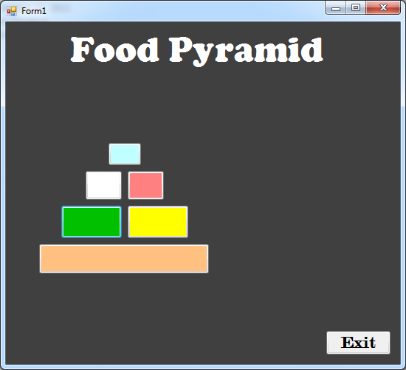

Private Sub btn11_Click(sender As System.Object, e As System.EventArgs) Handles btn17.Click

lblDisplay1.Text = "Fats, Oils and Sweets Group"

lblDisplay2.Text = "(Use Sparingly)"

End Sub

Private Sub btnExit_Click(sender As System.Object, e As System.EventArgs) Handles btnExit.Click

Application.Exit()

End Sub

Private Sub btn16_Click(sender As System.Object, e As System.EventArgs) Handles btn16.Click

lblDisplay1.Text = "Milk, Yogurt, and Cheese Group"

lblDisplay2.Text = "(2-3 servings)"

End Sub

Private Sub btn15_Click(sender As System.Object, e As System.EventArgs) Handles btn15.Click

lblDisplay1.Text = "Meat, Egg and Nut Group"

lblDisplay2.Text = "(2-3 servings)"

End Sub

Private Sub btn14_Click(sender As System.Object, e As System.EventArgs) Handles btn14.Click

lblDisplay1.Text = "Vegetable Group"

lblDisplay2.Text = "(3-5 servings)"

End Sub

Private Sub btn13_Click(sender As System.Object, e As System.EventArgs) Handles btn13.Click

lblDisplay1.Text = "Fruit Group"

lblDisplay2.Text = "(2-4 servings)"

End Sub

Private Sub btn12_Click(sender As System.Object, e As System.EventArgs) Handles btn12.Click

lblDisplay1.Text = "Bread, Cereal, Rice and Pasta Group"

lblDisplay2.Text = "(6-11 servings)"

End Sub

End Class